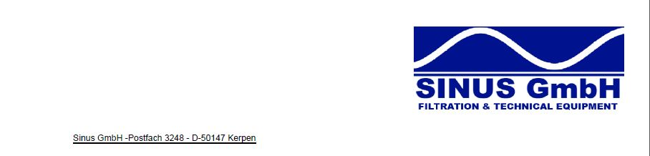

**Information about Sinus GmbH**

During the past few months Sinus has made a huge development. Sinus has hired new employees, extended their warehouse capacities and also its product range.

With the beginning of the summer in 2016 we will be moving our office including a much bigger warehouse.

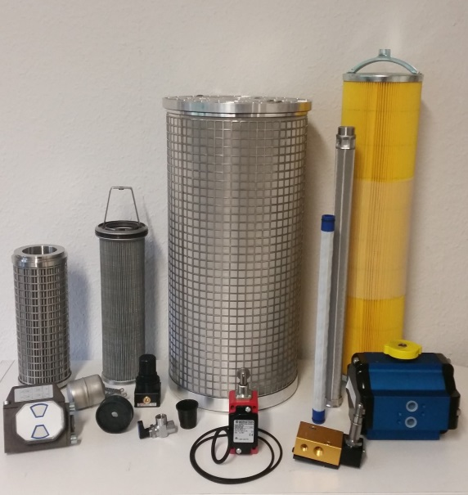Therefore we would like to point out that from now on we are able to supply spare parts of the following manufacturers beside our present product range:

**Automatic Filters:**

BOLL&KIRCH

Alfa Laval MOATTI

KANAGAWA KIKI

YOOWON

**FILTER FOR ENGINES:**

MAN B&W

WARTSILA

CUMMINS

HYUNDAI HIMSEN

**HYDRAULIC FILTER:                                                     OILY WATER SEPARATOR:**

HYDAC                                                                            RWO

PALL                                                                                BLOHM&VOSS

FRAMO                                                                           JOWA

EPPENSTEINER                                                             Mahle NFV

**COMPRESSOR SPARES:**                                               Others:

ATLAS COPCO                                                                Aura Marine

TAMROTOR                                                                    IMO

INGERSOLL RAND                                                         HVAC

KAESER SEA CHEST FILTER

... and many many more!