**Shanghai Goddaton Shipping Technology Co. Ltd**

Address: Room 412, Building 1 ,No.139 West Fu Te Road ,  Pudong New Area, Shanghai.

MOBIL: +86 13585839824

E-mail: [sales1_goddaton@sina.com](mailto:sales1_goddaton@sina.com)

SHIPSERV Trade Net:257462

Goddaton : Shanghai Singapore Germany Korea

• Spare Parts – Vessel

--STX engines

--Doosan-man engines

--Hyundai Man engines

-- DAIHATSU auxiliary engines

-- INCINERATORS and OILY WATER SEPARATORS-- FILTERS and FUEL SUPPLY UNITS

--LIFE RAFT and Accessories

-- DECK MACHINERY, CRANE and DAVITS

-- Electrical and Electronics-- Chinese equipment



• MAN Zhenjiang CME

• L16/24

• L21/31

• L23/30H

• L27/38

• L28/32

• L32/40

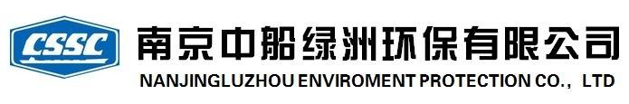• Incinerators (Teamtec)

– OG200C

– OG400C

– OG500C

• Oily Water Separators

• Sewage Plant

• Purifiers

• Deck Machinery

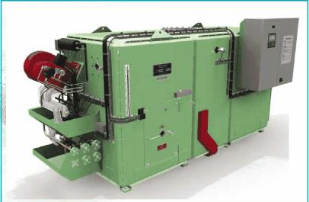



Oily Water Separator

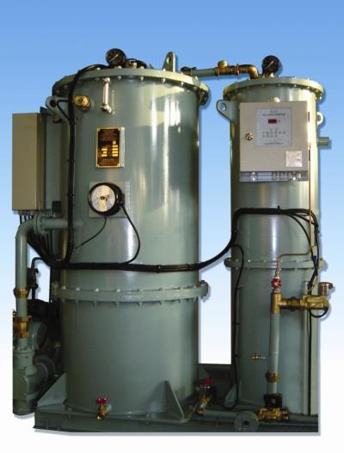

Purifier

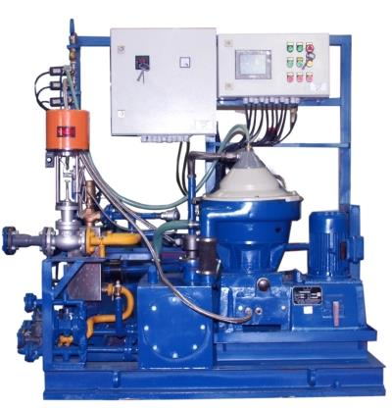

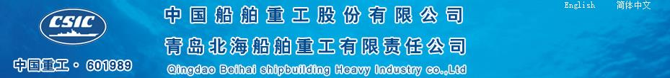

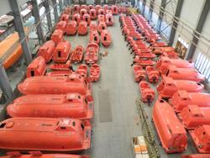

• QingDao BEIHAI, Jiangyin BEIHAI, Jiangsu Jiao Yan ,

– Lifeboats

– Davits

– Electricals



• Davit (swan)

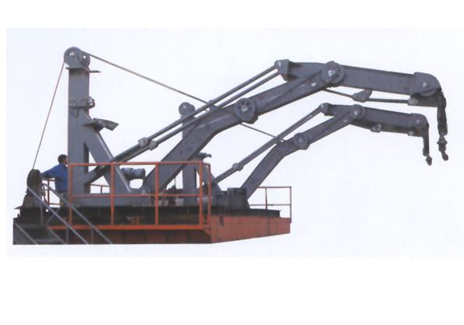

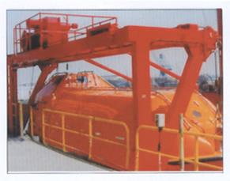

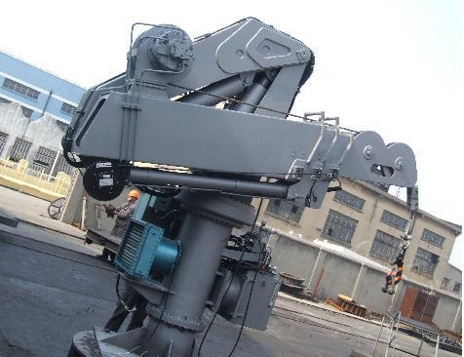

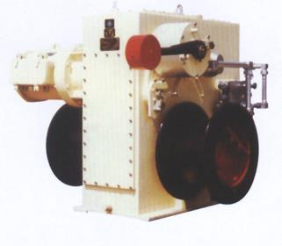

Other Items

• Steering Gear

• Electrical equipment

• Auxiliary Blowers

• Galley equipment

• Mooring Winch• Windlass

• Navigation & SearchLights

• Air Compressors

• Valve (Butterfly etc.) • Engine room Pump • Hydraulics (free fall

Lifeboat Davit)

Goddaton - introduction

Goddaton  Marine Service Company Ltd. (former name: Goddaton Marine) is one of the  marine service providers in China. We have offices in Shanghai,  Dalian, Qingdao, Zhoushan, Guangzhou,Nantong, Korea and Singapore. Following over 5 years’ of hard work and organic growth, our business has extended to the following: Automation service ,Safety Service, Spare Parts Supply, Engineering Service.

Service Network   
 Along with the tide of the Ship Building raise and trade prosperity in China, Goddaton enhanced its capabilities in the past few years. Headquarter in Shanghai Goddaton now has 4 offices located all in coastal cities throughout China. Hence our service can cover every port and shipyard in China.   
  
Product Diversity  
 For each berthing or docking vessel, we deeply understand that time is crucial to customers. To be a good “assistant” of customer, we strive to provide cost and time-saving services. Hence we keep increasing the variety of products and enhancing availability whenever a request is proposed. Our warehouse storage can cover 70% of daily order need.  
  
Spare parts supply  
 We have supply many spare parts about safety parts , main engine,Aux engine ,Automation parts to RMS,GMS in the past few years.we can offer Genuine and OEM parts .  
Category: Automation, Safety, Spare Parts, Engineering, Repair,  China, Korea, Singapore, Germany .