**SOLAS MAX Pilot Ladder**

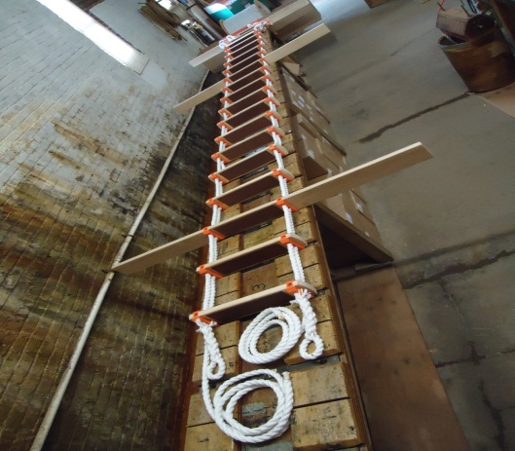

**SOLAS MAX Pilot Ladder**

**Manufacturer Certificate issued for all custom lengths.**

**ABS Product Development Assessment if required available up to 60ft.**

**Complies to latest revisions of SOLAS Reg. V/23 and ISO 799:2004**

13-3/4 inch step spacing

* The A. L. Don SOLAS MAX Pilot Ladder replaces the obsolete old style "Jacob's and Chain Suspension Ladder".
* SOLAS MAX Pilot Ladder has steps/spreaders of hardwood except for the bottom 4 steps that are made from Dupont® high impact strength surlyn HP or equivalent virgin Ionomer resin. All steps and spreaders are painted international orange.
* Non-skid grip applied to the surface of all steps using 2-part epoxy
* SOLAS MAX Pilot ladders have the A. L. Don patented clamp made from Dupont® high impact strength surlyn HP or equivalent virgin Ionomer resin that is designed for quick step replacement with no special tools
* The suspension rope is one continuous length on each side comprised of ¾” diameter 3-strand synthetic PolyPro-Dacron with a white outer jacket and an orange inner safety core.
* All Ladders are tested to 2000 lbs. Steps tested to 700 lbs. with no more than ¾” deflection.
* Replacement steps/spreaders are designed in the same manner as the original steps/spreaders to allow for quick replacement without unstringing the ladder.
* Standard lanyards consist of one 10 foot with seized end and one 12” (approx) lanyard with eye in accordance with SOLAS Reg V23 and ISO 799:2004 specifications. Other lengths available.

NOTE: Length of the ladder is configured in such a way that the first space is the distance from the water line to the first step, and the last space is from the top step to the deck e.g. based on our spacing of 13-3/4”, a 25 step ladder will cover a 30ft length excluding lanyards. (25 steps x 13-3/4” spacing= 343.75”)

[http://www.coastmarineonline.com/images/loading.gif](http://www.coastmarineonline.com/pilot.html)

[http://www.coastmarineonline.com/images/closelabel.gif](http://www.coastmarineonline.com/pilot.html)