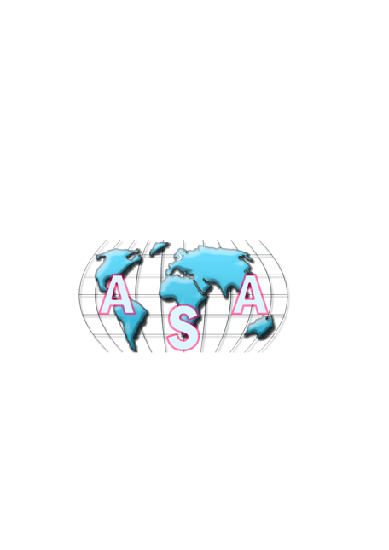 **Antares Shipping Agencies**

**Ship chandler – marine contractor – shipping Agency**

**Antares Shipping Agencies** – leading Ship Agents & Ship Chandlers providing

services in Suez & main Egyptian ports since 1992.

Our head office is located in Suez, Port Tawfik - we also have offices in Port Said, Alexandria, Damietta and Safaga.

Our services include: ship supply, ships repairs, marine contractors & shipping agents, salvage & loss assessment, crew change & repatriation, stevedoring, shipping consultants for govt. projects, customs formalities and clearing & forwarding.

Antares Shipping Agencies are fully licensed and accredited by the Egyptian government. Furthermore, we are ISO 9001:2015 & OHSAS 118001 accredited in addition to being members of ISSA & IMPA

**Our Aim:**

Antares Shipping Agencies constantly aims and strives to serve our clients with a reliable, cost-effective and timely service.

**Our Goal:**

Our Goal is for all clients we reach and who utilise our services, to be convinced to join our Antares Shipping Community, to be confident in our Agency and to continuously wish to appoint Antares Shipping Agencies as their trusted agents for any services required in Egypt and our Egyptian ports.

**Our Service:**

Antares Shipping Agencies offers a full range of shipping and port services and also acts on behalf of liner companies to represent their interests by facilitating ship arrival, clearance, loading and unloading in all major ports of Egypt and the Red Sea. Our services include: ship supply, ships repairs, marine contractors & shipping agents, salvage & loss assessment, crew change & repatriation, stevedoring, shipping consultants for govt. projects, customs formalities and clearing & forwarding.

**About Us:**

Antares Shipping Agencies was established in 1992 by Mr. Mohamed Ali whose experience in the Maritime industry comprises of 30 years of providing services to vessels in Egyptian & Red Sea Ports.

Mr. Mohamed Ali is a well-respected figure in the Maritime Egyptian community, in particular in his home town, Suez.

Through his perseverance, dominant local networking and personal relations with his clients worldwide, Mr. Mohamed Ali has positioned Antares Shipping Agencies as one of the most reputable and reliable shipping Agencies operating in Egypt.

### Ship Chandler: -

* + **Provision Stores: -**



**Fresh: -**

Our Fresh Items:   
Pumpkin Red, Bitter Gourd, Beans, Green, Cabbage, Cauliflower, Onion,   
Potato, Radish White, Beetroot, Carrots, Chili Green, Apple Red, Banana, Pineapple,   
Grapefruit, Water Melon, Mango, Orange, Grape Green, Garlic, Ginger, Lemon, Kiwi Fruit,  
Honeydew Melon, Plums Red, Potato Sweet Papayam, etc.



**Dry: -**

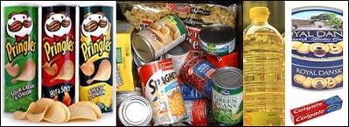Our Dry Items :  
Lipton Tea  Bag, Yellow Label   Coffee Mate , Nestle  , Coffee Creamer,    
Nescafe ,Instant Coffee   Milo, Milk Powder, Nido , Vinegar White  
Tomato Ketchup ,Chili Sauce  Tang Orange, Tang Lemon ,Tang Mango   
Oats, White, Oats, Quaker Cup Noodles Inst. Macaroni Elbow   
Spaghetti Vermicelli , Cooking Oil ,Soya Bean Oil, Sunflower Oil Pringles Cheese,   
Pringles Chips, Original   Tooth Paste, Colgate Tooth Paste, Close Up  Haldirams Aluo Bhujiab , etc.  
Butter Cookies

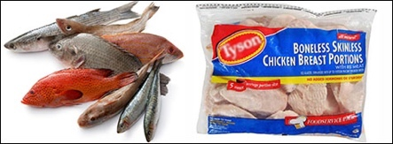

**Frozen: -**

Our Frozen Items:   
Ribbon Fish Whole , Cottle Fish, Prawns  
Red Snapper Fillet, Cod Fillet, Hamour Fillet  
Mutton Mince, Lamb Chopss , Butter, Unsalted,   
Mix Vegetable Frozen, Baklava Leaves  Samosa,  Vegetable, Butter, Salted     
Cauliflower Frozen , Ice Cream French Bread., Frozen , Half Baked, Chicken Whole, Griller,   
Chicken Sausages / Franks, Chicken Breast Boneless, Chicken Minced  
Beef Rump, Beef Silverside, Beef Brisket   Beef Shank , Beef Spare Ribs, Beef Sausage,   
Ice Cream Vanilla, Ice Cream Mango, Ice Cream Chocolate, Ice Cream Butter Scotch,  
Ice Cream Chocolate, Ice Cream Mango, Ice Cream Pistachio, Ice Cream Strawberry  
Frozen Oyster, Tuna Shashimi Fillet



**Chilled**

Our Chilled items :  
Eggs, Dry Anchovies Mars Chocolate, Quality Street, Red Bull  
Snickers Chocolate, Nestle Kit Kat, Cadbury Dairy Milk Cadbury Fruit N Nut Bar,   
Cadbury Fruit N  NutBounty Chocolate, Plain Yoghurt Sea Laver, Garlic Stem In Soy Sauce  
Dry Toyo, Cadbury Chocolate Toblerone Chocolate, Fruit Yoghurt Plain Yoghurt, Sea Lettuce ,   
Salted Belt Fish, Salted Sea Weed Stem, Seasoned Pollack Stripe Seasoned Sesame Leaf,   
Dried Squid Fish Unsalted Butter, Galaxy Jewels  Chocolate, Magnum Ice Cream.

* + 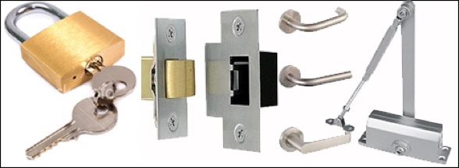**Cabin Stores: -**

**49-SERIES**

Mortise locks & latches Door lever handles & knobs   
Brass cabinet rings Door rings, Padlocks, Master key system padlocks,  
Door closers are part of our range of Hardware items.

### 51-Series-cabin

**51-SERIES**

We cover the entire range of:  
Paint brushes& paint rollers, Paint mittens, Aluminum extension poles,   
Nylon deck brushes, Non-spark deck brushes, Hand wire brushes,

Wire cup & Wire wheel brushes, (standard type, knotted type), Long & short handle brooms,   
Bath mats, Coir door mats, Deck rubber mats, Plastic sheeting, Corrugated rubber matting

**55-SERIES  
Complete range of Cleaning Materials & Chemicals**



* + **Medicines**
  + **Charts & Publications**
  + **Marine Container**
  + **Supply / Installation of Radar / Gyro Compass**
  + **Supply / Installation of Auto Pilot and All Other navigational Equipment’s.**
  + **Technical Equipment’s and Oxygen, Acetylene and Freon Gas.**
  + **Safety Stores: -**

### 33-Series

**33-Series**

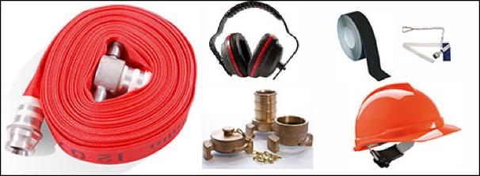We stock a range of products ranging from   
Life Jackets, Lifebuoys, Reflective tapes, lifeboat torches, immersion suits,   
Life boat anchors, Life boat jack knives, Life boat ditty bags,   
Fire hoses, All-purpose nozzles,   
3 Position fog nozzles, All types of hose couplings, fire axes,   
Safety belts & hooks, Dust protecting masks,   
Paint spray respirators, plastic chipping goggles, Noise foe ear muffs,   
Earplugs, Safety helmets, Antislip tapes.

### 37-SeriesElectrical Stores: -

**37-SERIES**

We stock a complete range of :  
Navigation Lights, Green Flashing Lights,   
Red Flashing Lights, Suez Canal Searchlights, Day Signals, Full range of merchant flags & flag hooks & Blocks

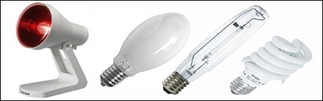**79-SERIES  
We stock the complete range of electrical items as per the list below:**

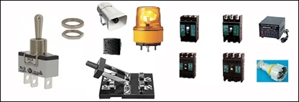All types of lamps such as   
Flat reflector lamps ,Infrared lamps, Mercury lamps, Self-ballasted mercury lamps,  
High pressure sodium lamps ,Tungsten halogen lamps, Sealed beam lights, Florescent Lamps,  
Along with all the necessary accessories, Reflection lamp lighting fixtures  
Flood lighting fixtures, High pressure sodium flood lights, lighting fixtures,  
Explosion proof fluorescent ceiling lights, Cargo lights,  
Boat deck lights Projection lights. , Marine deck lights , Marine water tight wall light,

Explosion proof hand lamps.  
Bright star flashlights

**All types of Batteries:**

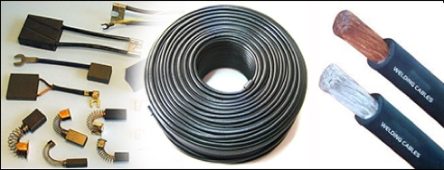

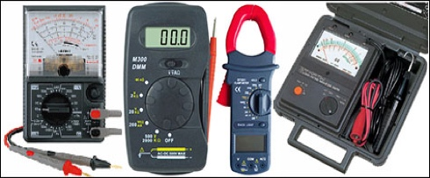Battery chargers,  
complete range of marine water tight Plugs +Receptacles,  
Marine water tight rotary switches, Toggle switches, Push button switches,  
Knife switches, No fuse circuit breakers, Low voltage converters,  
Marine electric alarm buzzers & alarm bells, Water tight electric horns,  
Lamp holders , Cello light fuses, Carbon brushes, Welding cables,  
Rubber cab type cables, P.V.C cab type cables,  
Armored cables, Copper markers, Cable glands, Marine water tight junction boxes,  
Antenna cable insulation, Bakelite rods & sheets,  
Electric sleeve tubes, Clamp meters,  
Avo meters, Digital multimeters, Insulation testers.

* + **Deck Stores: -**

**19-SERIES**

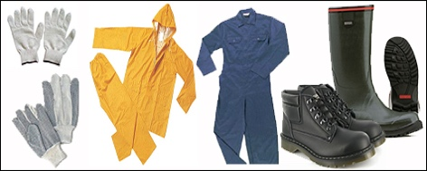Assorted Range of:  
Gloves Cotton, Rubber coated Gloves, Non-Slip dotted Gloves, Winter Gloves, Leather Palm Gloves, Natural Rubber Gloves & Oil/Acid Gloves.  
  
Our Safety shoe / Boot range consists of: -  
Rubber Boots, Safety Shoes, Safety work Boots, Oil/Acid Resistant Boots & Shoes  
  
Also Available Rain suits with Hood, Boiler suits (Cotton + Polyester) in all colors,   
Parka Jackets & Refrigerator Coats.

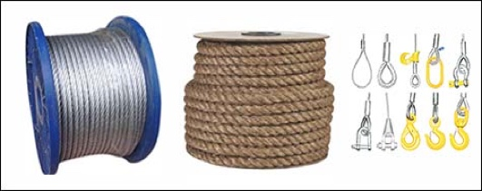

**21-SERIES**

**All Ropes are available with test certificates.**

We cover the complete range of:  
Wire Ropes, P.P. Ropes, Manila Ropes, Nylon Ropes, Mooring Tails, Wire Rope slings, Tonsberg mooring Links, Fairlead Mandal Shackles, Heaving Lines, Signal Halyards, Tarred Marline, Sailtwine & Seizing Wire.

**23-SERIES**

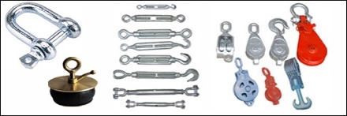Consist of a complete range of:  
Shackles, Turnbuckles, Tonsberg, Mooring Links, Mandal Fairlead, Fairlead Shackles, Deck Lashing,   
Turn Buckles, Rigging Screws, Wire Rope Clips, Wire Rope Thimbles &Manila Rope, Thimbles, Safety Latch Hooks, Swivel Safety Cargo Hooks, Deltaplates, Alloy Chains.   
We also carry a complete range   
Steel Cargo Blocks, Guy+Snatch Blocks+Wooden Blocks, Cargo Safety nets, Nylon Slings, Endless Type Sling, Waterproof Canvas, Tarpaulin, Scupper Plugs, Oil Absorbent Sheets, Oil Absorbent Pellets, Oil Blooms, Hatch Cover Tape

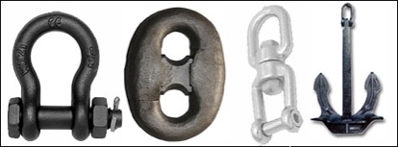**Specialty products are:**  
  
Container lashing & securing Gears like Twistlocks, lashing rod long, Lashing rod short,

Turnbuckles, Single stacker, Double stacker, Bridge fittings, Actuator poles,    
Extension rods, Corner hooks, Lashing eyes & lashing chains.    
  
**Anchor chains**   
  
Joining shackles, Anchor shackles, Kenter shackles, Swiver shackles, Chain stoppers stockless Anchors.

**35-SERIES**

Our range consist of the following: -  
  
Rubber Air Hose, Welding hoses, Corrugated Rubber hose, PVC water suction/Delivery Hose, Steam Rubber Hose, Chemical Rubber Hose, Oil Transfer Hose, PVC Air duct Hose, PVC industrial hose,   
hydraulic rubber hoses.  
Coupling range is follows: -  
Lock Air Type Hose Coupling, Universal Air Hose Coupling, Quick Connect Couplers

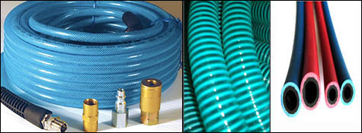

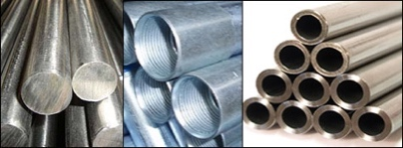

**71-SERIES**

We hold Mild Steel    
Sch 40 + Sch 80 seamless pipes upto 14”.   
Hydraulic Mild Steel Pipes, Stainless steel 316L + 304L pipe IN Sch 10, Sch 40, Sch 80, Seamless Copper Tubes,   
Alu-Brass Tubes

**73-SERIES**

**To support our large pipe stock, we also have the complete range of fittings such as**

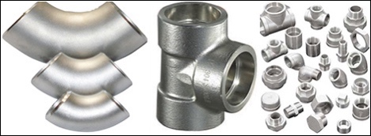Elbows, Tees, Sockets, Reducing Sockets, Hexagon Bushings, Square head plugs, Union, Short + Long nipples,   
Flanges, etc. In addition, we also hold pipe coupling + joints.

**75-SERIES**

**We are one of the largest Stuckist’s of Valves in the Middle East. This stock includes the following: -**

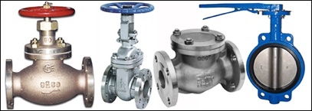

Marine Bronze Valves (Globe + Angle Type) 5K, 10K, 16K, 20K

Marine Cast Iron Valves (Globe + Angle Type) 5K, 10K, 16K, 20K  
Marine Cast Steel Valves (Globe + Angle Type) 5K, 10K, 16K, 20K  
Marine Cast Iron & Cast Steel Gate Valves (Butterfly Valves Lock Lever + Worm Gear Type)  
  
Our range of valves is from 1/2” to 24”.  
Also included in our stock of

valves are lift check valves, Swing check valves, Safety relief valves, Bronze cock valves, Hose valves, diaphragm valves, pipe line & strainers,Steam traps, Air-vent heads oil Flow meters and indicator cocks.

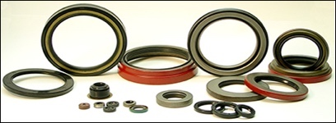**81-SERIES**

We are the authorized agents for **Chesterton Marine Packing.**

Along with Chesterton we also stock various other brands.   
Our range includes   
Graphite packing,  Ramie packing, PTFE Ramie packing, PTFE fiber packing, Asbestos free Aramid packing,     
Stern gland packing, Water packing, Tank lid packing, Universal asbestos joint sheets, Steam asbestos joint sheets,   
Wire interwoven asbestos joint sheets, Compressed asbestos Fiber jointing, Oil resistant joint sheets,   
Asbestos free gasket joint sheets, Cortex joint sheets, Natural rubber joint sheets,  Semi metallic gaskets,   
Flange gaskets, Thistle bond products, Uni metal, Anti corrosive tapes, Teflon cords, Teflon rounds,   
Teflon sheets, ‘O’ rings, Rubber strings, ‘O’ ring splicing rits, Copper ‘O’ ring kits, LODFAH sponges

* + 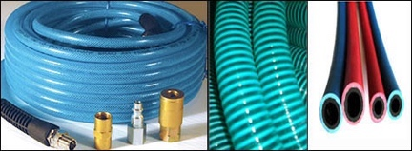**Engine Stores:-**

**35-SERIES**

Our range consist of the following: -  
Rubber Air Hose, Welding hoses, Corrugated Rubber hose, PVC water suction/Delivery Hose, Steam Rubber Hose, Chemical Rubber Hose, Oil Transfer Hose, PVC Air duct Hose, PVC industrial hose, Hydraulic rubber hoses.

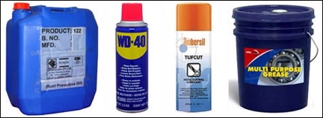

**45-SERIES**

Our range consist of the following: -  
Penetrating Oil, Multi-Purpose Grease, Rust Preventives, Gear Grease, Bearing Grease,  
Wire Rope Grease, Fish Oil & Tallow

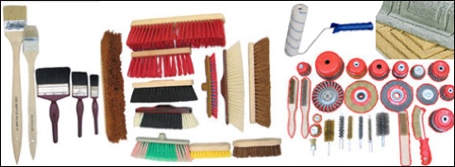

**51-SERIES**

We cover the entire range of  
Paint brushes& paint rollers, Paint mittens, Aluminum extension poles,

Nylon deck brushes, Non-spark deck brushes, Hand wire brushes, Wire cup & Wire wheel brushes, (standard type, knotted type),    
long & short handle brooms, Bath mats, Coir door mats, Deck Rubber mats, Plastic sheeting, Corrugated rubber matting.

**59-SERIES**

**Pneumatic Tools list**

Pneumatic Impact Wrenches + And its Accessories, Pneumatic Angle Grinders + And its Accessories, Pneumatic Die Grinders, Pneumatic Straight Grinders, Pneumatic Hand Drills, Pneumatic Chipping Hammers + And its Accessories,

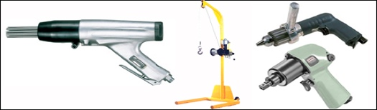Pneumatic scaling Hammers + And its Accessories (Kobe - Japan), Pneumatic Deck Scalers +   
And its Accessories (Kobe - Japan), Pneumatic Jet Chisels + And its Accessories,

Explosion Proof Air Saws (Fuji-Japan),

Pneumatic Driven Mucking Winches and its Accessories (“Skatool “-Singapore   
Universal winch co.), Tank Cleaning Machines And Its Accessories. (Cloud-USA),  
High Pressure Spray Cleaners (Jet Cleaners) “Kranzle” (Germany),  
Air Turbine Ventilators - “Latintec” (Argentina), Water Driven Turbine Fans - “Lantitec” (Argentina),  
Air or Steam Driven Turbine Fans - “Lantitec” (Argentina),  
Diaphragm Pumps - “Versamatic” (USA), Pneumatic Sumps Pumps - Tsurumi (Japan),  
Pneumatic Drums Pumps - (Korea), Pneumatic Chain Hoists - “Budgit” (USA), “Bando” (Korea) .

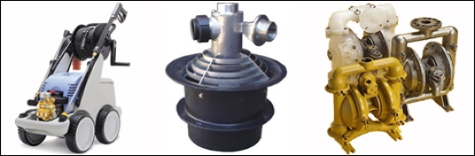

**Electrical Tools**

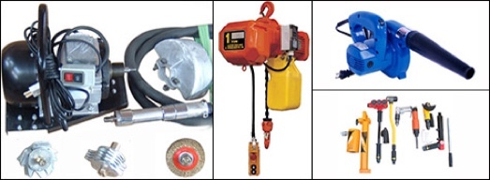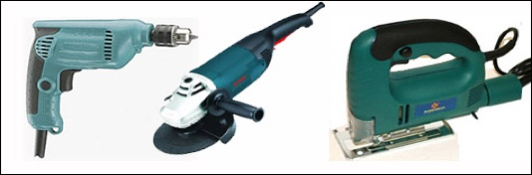Portable Electrical Drills (110V + 220V) + Accessories,  
Electric Angle Grinders (110V + 220V) + Accessories,  
Electric Straight Grinders (110V + 220V) + Accessories,  
Electric Hand Grinders  (110V + 220V) + Accessories,  
Electric Circular Fans (110V + 220V) + Accessories,  
Portable Electric Jig Saws (110V + 220V) + Accessories,  
Portable Rod Cutters  (110V + 220V) + Accessories,  
Electric Blowers  (110V + 220V) + Accessories,  
Electric Scaling Machines  (110V + 220V) + Accessories(“Kobe - Japan + Sratool - Singapore),  
Electric Chain Hoists - “Budgit ”(U.S.A.) “Bando” (Korea),  
Electric Portable Ventilation Fans (110V + 220V) + Accessories

**61-SERIES**

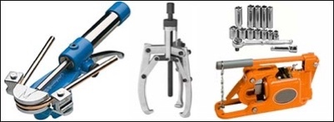Holding a comprehensive range of all tools from reputed suppliers such as " Bahco" (Sweden), "Carl Walter" (Germany), "Super" (Japan) to an a few.

Our range consists of:   
Socket Wrench Sets, Power Wrenches, Straub Coupling, Double open end Wrench sets,  
Valve Wheel Wrenches, Hexagon Bit sets, Allen Hexagon Wrench set, Adjustable Wrenches,  
Torque Wrenches, Different types of hammers, Drum hooks, Punching Tools , Hydraulic Wire Rope cutter,

Hydraulic Pipe bender, Hydraulic bearing puller

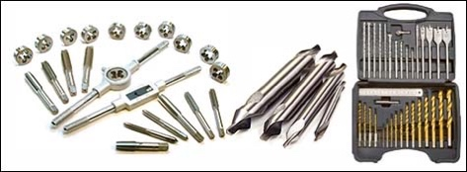

**63-SERIES**

Our range consists of:  
  
Machine tool bits, Rotary Carbide burrs, Center Drills, Rolling Center, Tap & Die sets, Drills & Drill sets, Dividers

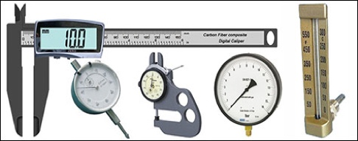

**65-SERIES**

This consists of all types of:  
Calipers, Inside + Outside Micrometers Vernier calipers, Digital Calipers, Thickness gauges,   
Oil Gauging Tapes, Combination Square sets, Dial Gauges, Complete range of pressure Gauges,   
Thermometers, Engine Indicators, Pyrometers, Pressure Calibrators, Temperature Calibrators

**Marine Contractors:**

* **Garbage Collections**
* **Sludge, Slopes, Water**
* **Tug boat Hiring**
* **Tanks Cleaning**
* **Underwater Welding**
* **Spare parts**
* **Spares of Engines**
* **Compressors**
* **Hydraulic Motors**
* **Technical Services**
* **Electric Motor Rewinding with F Class Insulation**
* **Approved Cargo Gear Testing**
* **Annual Inspection of Navigational Equipment’s**
* **Spare Clearance**
* **Spare Forwarding**
* **Clearance of Spares from Airport to Ship And Vice Versa**
* **Storage of Spares in Custom Bonded Warehouse**
* **Annual Inspection**
* **Servicing of CO2 System**
* **Fire Extinguishers**
* **Marine Civil Engineering**
* **Life Rafting Service Approved by Various Classes and Government**
* **Marine Demolition**

**Contact US:**

**Antares Shipping Agencies Co**

📱 +201223242093

☎️ +2 06 23 195 490 / +2 06 23 193 322

📠 +2 06 23 193 101

📧 [info@antaressuez.com](mailto:info@antaressuez.com)

[info@antaresegypt.org](mailto:info@antaresegypt.org) ,

operation@antaressuez.com

[antaresshipping@antaresshipping.com.eg](mailto:antaresshipping@antaresshipping.com.eg)

🏢 El Fanarat St, Gate No. 9, El Dobbat Building No. 5,1st Floor, Flat No. 3 Port Tawfik, Suez, Egypt



