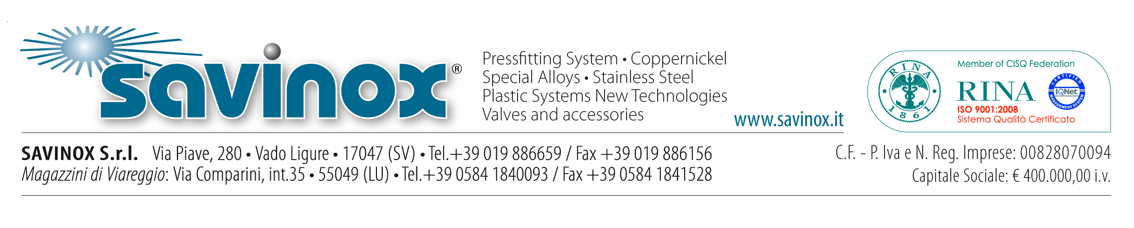

SAVINOX S.r.l.

I. Introduction and History

SAVINOX S.r.l. is a trading company based in Vado Ligure (Savona - IT).
It was founded in October 1986 by the Ottonello family and launched on the market in January 1987 to deal with the supply of products such as pipes, tubes, joints, fittings, sheet metal and stainless steel bars to local chemical and metal producing factories (i.e. Montedison and Italsider).

The severe industrial crisis which hit the market at the end of the 80’s caused most of the local companies to close down and subsequently led to a contraction of SAVINOX’s main reference market. Mr. Ottonello was then forced to search for new targets and markets which he then found in the shipbuilding industry sector, namely as a supplier of such special stainless steel alloys as Duplex and/or SAF 2205 used for building chemical tankers.

With time, the operation and the expertise of Savinox has also expanded into supplying major international naval shipbuilding facilities, specialized in the construction and repair of cruise ships, military vessels and offshore units. Further, SAVINOX has equally supported the most prestigious Italian and European shipyards for yacht building of all sizes.

The response from the naval industry was extremely positive and this led to a healthy increase of the range of products supplied. SAVINOX subsequently became one of today’s leading companies for the supply and distribution of shipbuilding materials.

These are the main steps of our growth and development in our market industry:

1992 – Larger headquarters are inaugurated to better manage all operations;
1993 – CEO-to-be Engineer Francesco Serra was hired;
1994 – 90/10 Copper-nickel products (used for sea-water piping) are added to the range of products supplied;
1995 – SAVINOX becomes EUCARO BUNTMETALL GmbH agent and distributor for 90/10 Copper-nickel alloys;
1999 – SAVINOX is awarded RINA ISO 9002 Quality-Management Certification (presently replaced by RINA ISO 9001:2008);
2000 – SAVINOX starts selling and distributing GEBERIT MAPRESS pressfitting products;
2001 – a new 1000 sq. mt. warehouse, adjoining the previous premises is inaugurated;
2003 – SAVINOX becomes GEBERIT’S naval products distributor;
2004 – the company's computer system and network undergoes massive update and a new management software is installed in order to better respond to the customers’ requests;
2005 – SAVINOX becomes GEORG FISCHER S.A.’s distributor;
2006 - SAVINOX becomes LOROWERK GmbH’s distributor;
2007 – SAVINOX becomes NOVOPRESS GmbH pressing tools Maintenance and Repair centre;
2010 – SAVINOX becomes CHIBRO S.p.A.’s (presently ILTA – Chibro - ARVEDI Group) distributor;
2011 – a new warehouses is inaugurated in Viareggio to better meet the needs of the yacht, super-yacht and mega-yacht building industry;
2011 - XM19- Nitronic 50® super-austenitic stainless steels for petrol-chemical industries are now distributed from the new warehouse equipped with a cut line plant built next to the former facilities in Vado Ligure;
2011 - the company’s computer system and network is updated to ARCA Evolution system;
2012-2013 – the press-tool and plastic welding-tools repairs workshop is renovated and enlarged;
2014 – a new bronze/brass product line is started at Viareggio’s warehouse where a new mezzanine is built.
2016 – set up of 2 vertical automatic warehouses (Modula) for the storage and integrated management of materials nearby our headquarter in Vado Ligure.

II. Type of products marketed

The products distributed and sold by SAVINOX - and usually kept in stock at the company’s warehouses in both Vado Ligure and Viareggio - are the following:

- Standard-compliant weldless and electrofused pipes (304/304L/316/316L/316Ti/321- Stainless Steel, 90/10 Copper-nickel-Aluminium);
- Fittings: bendings, concentric and eccentric reducers, collars, stub-ends, tee-joints, etc. (304/304L/316/316L/316Ti/321 Stainless Steel- 90/10 Copper-nickel-Aluminium);
- Carbon Steel, Stainless Steel and aluminium flanges;
- Sheet metal and tie bars (Stinless Steel, 90/10 Copper-nickel, Aluminium);
- Standard sized laminated flat sheets, elbows and squares;
- Special alloys (XM19, NITRONIC 50®);
- Stainless Steel, copper, copper-nickel Pressfitting System;
- Novopress Press-fitting tools;
- Industrial and naval valves (butterfly, UNAV, ball, wafer);
- Normaconnect joints;
- Hermetic thru-bulkhead feedthrough;
- Georg Fischer plastic pipe systems (Aquasystem, Instaflex, I-Fit, HDPE etc.) Geberit Mepla and PE.
- Bronze and brass fittings GUIDI s.r.l..

III. Target Markets and customer portfolio

As reported in the short introduction and product type list above, SAVINOX mainly addresses the shipbuilding and ship-repairs sectors (cruise ships and leisure vessels) as well as super-yacht, mega-yacht and giga-yacht builders.

Part of our business activity is also focused on the industrial sector (oil & gas and piping)

In such a diversified context, SAVINOX is also the supplier of many Italian and foreign shipyards, both directly and as a supplier of subcontractors specialized in the installation of hydraulic systems with which SAVINOX has developed, over time, continuous collaborative relationships also from the in consultation of new products, new materials and new industry technologies.

Below are SAVINOX´s most representative Customers of the Naval sector:

Gruppo Ferretti with the following shipyards: CRN, Riva, Pershing, Custom Line, ITAMA, mochi craft;
Gruppo Azimut Benetti;
San Lorenzo YACHT;
Pisa Superyachts;
Codecasa yACHT;
Nuovi Cantieri Apuania S.p.A. – Admiral;
EUROCRAFT CANTIERI NAVALI S.R.L.;
MONDO MARINE S.P.A.;
FINCANTIERI S.P.A.;
CARNIVAL CRUISES LINES (Carnival Cruise Lines, Costa Crociere, Princess Cruises etc.);
T.MARIOTTI S.P.A;
SANGIORGIO DEL PORTO S.P.A.;
MONACO MARINE S.A.;
C.N.ULJANIK;
3 MAY ;
LP BRODOGRADILISTE SHIPYARD;

BRODOSPLIT- BRODOGRAĐEVNA INDUSTRIJA SPLIT D.D..

Clients from the industrial sector:
PENTAIR VALVES & CONTROLS ITALIA SRL VANESSA;
OFFICINE MECCANICA SALERI;
ORTON VALVOLE S.R.L.;
WORTHINGTON S.R.L.;
POMPE GARBARINO S.P.A.;
FLOWSERVE S.P.A.;
IV. Structure and headcount

SAVINOX is currently organized as follows:

Premises:

3000 sq. mt.: warehouses for stocking goods,
200 sq. mt.: offices
100 sq. mt.: press workshop

Operative structure:
3 overhead travelling cranes,
4 fork lifts,
3 trucks,
2 cut lines

Staff (see the organization chart below):

6 sales executives
4 administrative employees,
2 shipping and certification employees,
1 workshop technician,
1 driver,
6 warehouse employees.

The Company is led by a 4 member Board of Directors with Mr. Ottonello serving as President and Legal Representative and Engineer Mr. Francesco Serra serving as CEO.

SAVINOX S.r.l. Organisational Chart

Board of directors
CEO
Francesco Serra
Stainless steel & Steel division
Angela Palombino
Andrea Segarich

Div. Cuni Cupronichel Geberit Mapress New Products
Francesco Serra
Andrea Giuliani
Alberto Visentin

Div. Special alloys
Ezio Fassino
Promotion & planning
Pietro Degani
Quality Mng
Marco Arca
President
Luigi Ottonello
Safety Mng
Roberto Parodi
Finance & Admin
Debora Patatti

Workshop Mng
Maurizio Polito
Warehousing./
Forwarding Maintenance
Christian Rossello
Finance& Admin staff
Daniela Delfino
Elide Panigo
Barbara Panigo
Warehouse Vado staff
F. Oprea – L. Perrozzi – M. Zanella – M. Fassino – L. Bruno –
B.D Representative
Francesco Serra
Resp. Documentation
Frediano Frumento
Warehouse manager Viareggio
Eraldo Merlini
Cut line plant
Florian Oprea
Warehouse supervisor
Emanuele Baricca

V. Our main Partners and Suppliers

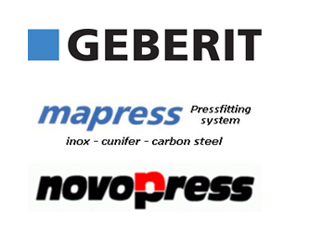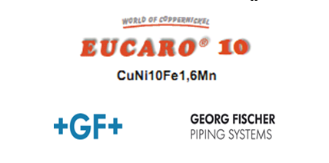

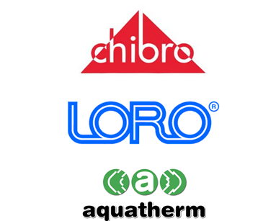

VI. Value proposition and competences: the DNA of SAVINOX

Our experienced management dedicated to follow up on the evolution of the market needs, together with a total care in managing our company organisation, has allowed SAVINOX to gain, in thirty years of experience, excellent results in the naval and industrial sector both in Italy and abroad.

SAVINOX with the competence, leadership and experience of its own management and staff, has been able to improve and increase its presence and image in the market as an operator recognized and appreciated globally. It has always maintained a high degree of independence and flexibility which enabled the opportunity to rapidly gain momentum in the expanding markets and to exit, without negative impact, from the declining sectors (such as the industrial sector's crisis related to oil extraction and processing).

The continuous developments, the overall growth since its establishment, the strong and positive results obtained from the company, are mainly due to a commercial and operational management policy based on the customer's satisfaction.

Key success factors:

- the availability of a wide and full range of high quality products thanks to solid and privileged business relationships, lasting over twenty years, with the leading manufacturing companies in the sector;
- the efficient management of the warehouse and the ability to execute orders with fast delivery of products worldwide in the naval sector;
- the integrated technical consulting service based on quality, characteristics, new technologies and the use of products and materials, resulting from a thirty years of experience jointly with a significant technical expertise, difficult to find in other companies operating in same field.

Our products, our capability to quickly and effienciently deliver worldwide together with our consulting experience have created a unique and winning company in the market.
VII. Financials: general management and revenue considerations

As indicated in the below charts, over the last decade, SAVINOX's inventory has been intensely constant, with a peak in 2011, due to the establishment and the supply requirement of the new warehouse of Viareggio and the fast development of the special alloy market that allowed SAVINOX to achieve - in those years - very positive results in terms of revenue growth and margins.

With reference to the turnover, SAVINOX has been able since its establishment to continously grow. However, in the years following 2013, the Company recorded a decline in revenue attributable almost entirely to the market reduction of the special alloys market, linked to the global crisis in the oil sector; This reduction in volumes origin was also absorbed without any particular consequences, as evidenced by the substantial stability of the main economic margins over the last three financial years

SAVINOX has consolidated its sales volumes around 10 million Euros in the recent years. From the point of view of the composition of turnover, the main revenue centers nowadays consist of cunifer, plastics and pressfitting which, together, represented in 2016, altogether, 71% of total sales.

Efficiency in process management is well represented and synthesized by
Warehouse Rotation, which in 2016 and on average over the last decade has stood at values around 3.3. Efficient process and stock management enables the company to provide customers with technology and materials consulting, making the overall offer very appealing.

The need to maintain inventory at levels that ensures rapid delivery and efficiency, which is a key element in value creation by SAVINOX, recognized by customers and stakeholders, leads to the absorption of significant financial resources.

The charts below show the main business data mentioned.

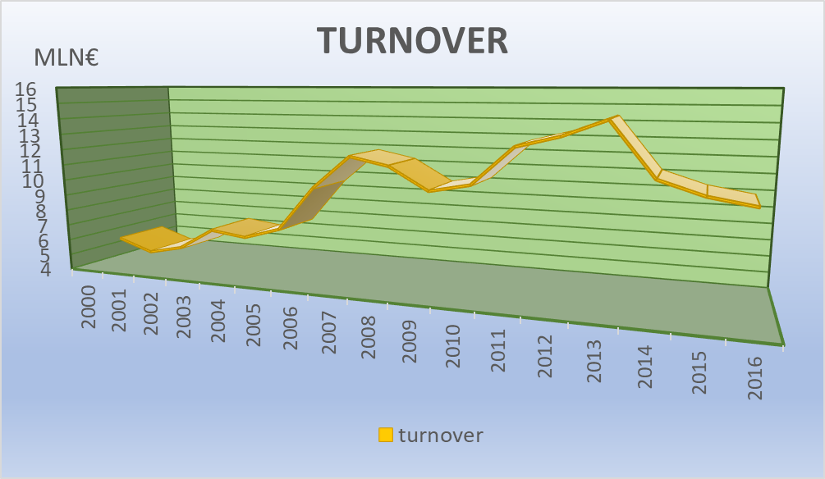

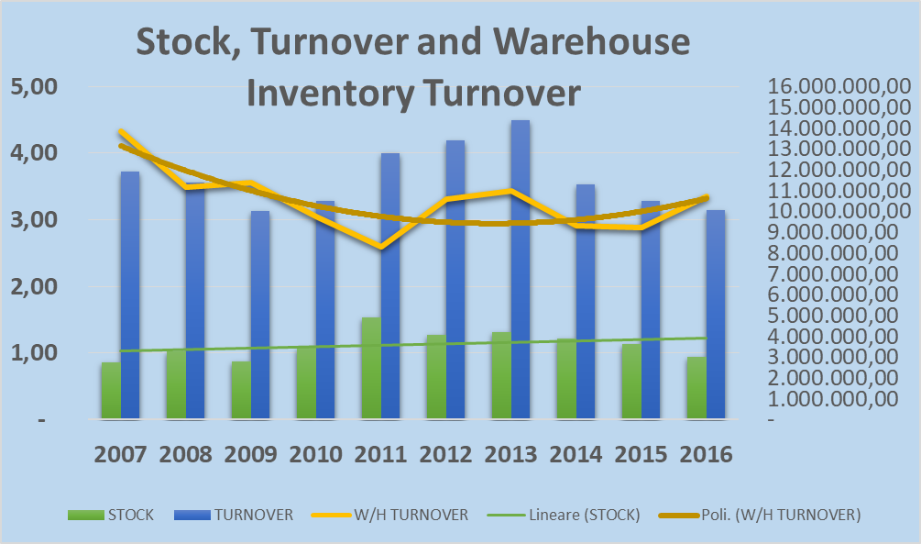

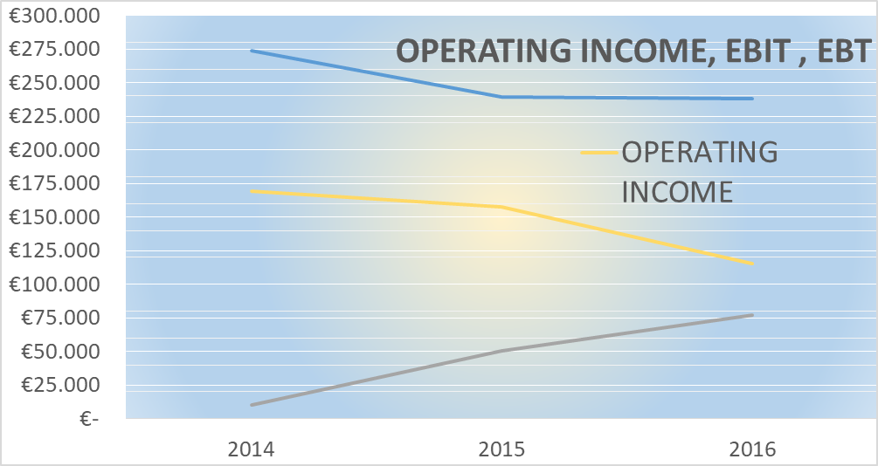

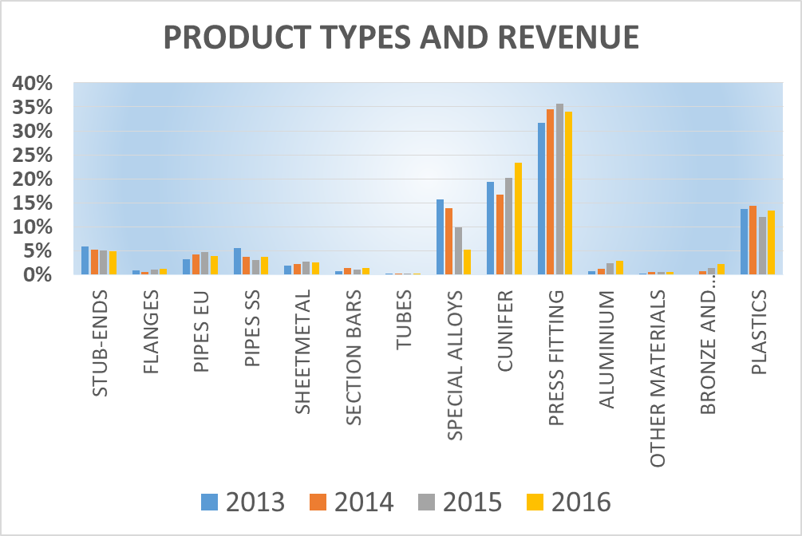

VIII. The future of SAVINOX: new markets

The construction and repairs of cruise ships (cruises & leisure vessels) and of vessels with complex systems and installations (i.e. warships) represents the main market and the core business for SAVINOX today and in the future.

One of SAVINOX´s main customer, the Carnival group, is planning to build 17 new cruise ships by 2020, to be added to the 100 vessels already in the fleet and that on require maintenance, repair and refitting procedures.

In the recent years the industry of cruising and leisure vessels is opening up on new markets with significant opportunities for development and growth.

Some Italian and European naval shipbuilding companies, specialized in building and repairing commercial vessels, military vessels and offshore, following international expansion strategies, have signed and are developing technical and commercial partnerships with major shipyards in the far east: this refers notably to China which, today, is unanimously considered a market with high growth potential.
As an example, in July 2016 Fincantieri S.p.A. and China State Shipbuilding Corporation (CSSC), the largest shipbuilding conglomerate in China, signed an agreement to set up a joint venture for the development and growth of the cruise industry of China.

For the first time in the history of shipbuilding, customised cruise ships will be built in China exclusively for the Chinese market. This agreement provides the specific consulting support of Fincantieri in terms of shipbuilding techniques and services.

The presence of SAVINOX in these "new" industrial and economic scenarios can generate an important growth and development opportunity for the company that would have the possibility to offer on these new markets the following key value elements:
- Managerial know-how;
- The privileged commercial relations with strategic suppliers and leading manufacturing companies in the naval sector.
- Product, materials and new technologies knowledge and expertise.
- The possibility of replicating “the SAVINOX model" on the new Asian markets both in terms of business model and in terms of working methods (i.e. stock supply, stock rotation and storage of materials).

The structure, the organisation and the international scope of SAVINOX allows the company to reach out to and expand in the new emerging markets worldwide.

IX. The future of SAVINOX: new products

With the constant focus of increasing the offered services and value propositions to customers, a few months ago, SAVINOX has started important collaborations with leading multinational companies specialised in the production of plastic materials with the aim of establishing and developing new products and innovative solutions increasing efficiency and price competitiveness in the marine industry.

These new product lines (plastic pipe and fittings) have been developed to be installed on board to replace metal products, both on new buldings or during dry docks, and they represent an important added value offered by a vendor that operates in this area.
The new plastic product lines are already highly appreciated by the main market players and they have been recently presented to international exhibitions (the SeaTrade Miami 2017 Fort Lauderdale Florida USA) receiving extremely good feedback from several companies who have already used them and installed them.

It is the belief of the management SAVINOX that these new product lines, if supported by an adequate marketing plan and business development, due to their characteristics, their innovative character and being products created and designed with the advice and expertise of experienced and competent operators, will ensure the company to retain important shares in that market.

For these reasons, SAVINOX will always be carefully dedicated to research, promotion and development of commercial synergies and new projects.

